 

**Placement Empowerment Program**

***Cloud Computing and DevOps Centre***

* **Automate Static Website Deployment Locally Create a script that updates your server whenever changes are pushed.**

Name: Sanjay Raj S Department : IT



**Automate Static Website Deployment Locally**

**Prerequisites**

* Install **Git** ([Download Git](https://git-scm.com/downloads))
* Install **Node.js** ([Download Node.js](https://nodejs.org/))
* Install **Python** (if required for scripting) ([Download Python](https://www.python.org/downloads/))
* Install a static site generator (e.g., Hugo, Jekyll, or Gatsby)

**Step 1: Create a Static Website**

For this example, we use Jekyll (you can use any static site generator).

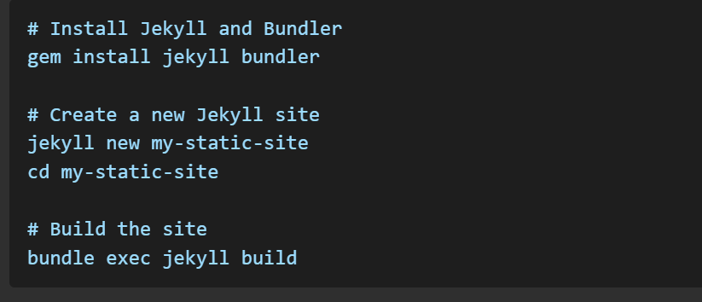

**Step 2: Initialize a Git Repository**

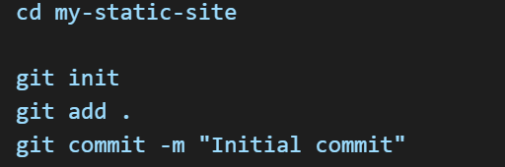

**Step 3: Create a Deployment Script**

Create a file named deploy.sh in the root of your project.

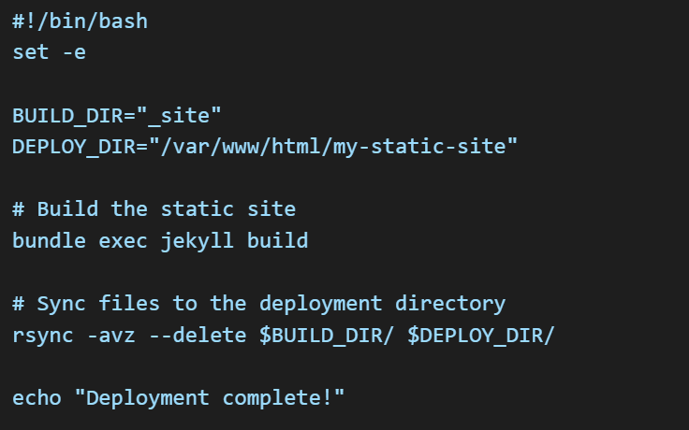

Make the script executable:



**Step 4: Automate Deployment Using Git Hooks**

To automate deployment when changes are committed, use Git hooks. Create a post-commit hook:

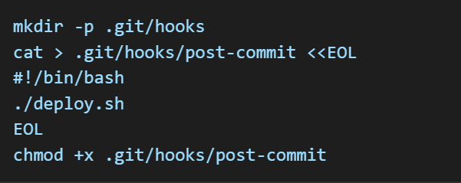

**Step 5: Test the Automation**

Make some changes to your site, commit them, and check if deployment happens automatically.

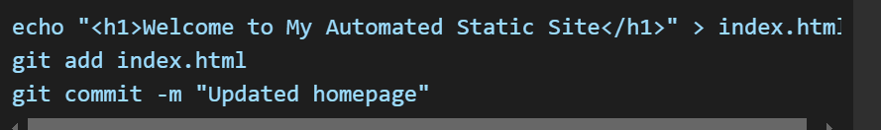

This should trigger the post-commit hook and deploy the website locally.

**Conclusion**

Now, whenever you commit changes to your repository, your static website will be rebuilt and deployed automatically to the local server. You can extend this by integrating CI/CD pipelines or deploying to remote servers using tools like GitHub Actions or Jenkins.